SQL Assignment – 4

1. Write a select command that produces the order number, amount and date for all rows in the orderes table

ans
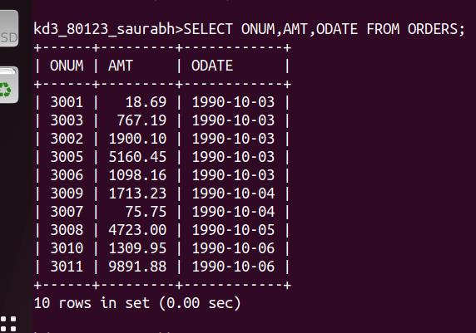
2. Write a query that produces all rows from the customers table for which the salesperson number customers table for which the salesperson number is 1001;
ans:
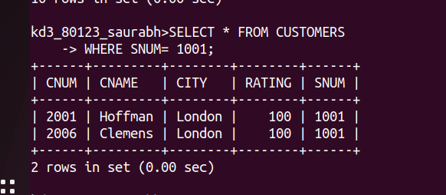

3. Write q query that displays the salespeople table with the columns in the following order city, sname, snum , comm
Ans-

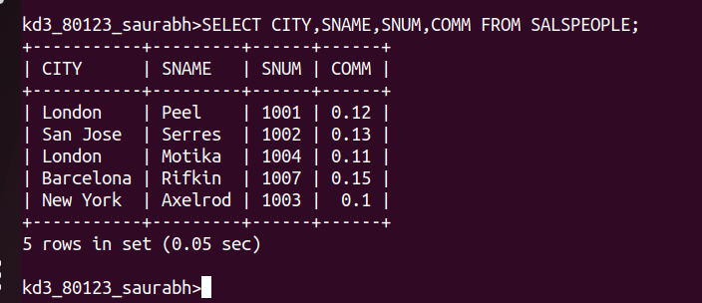

4. Write a select command that produces the rating followed by the name of each customers in San Jose

